**WEB ENGINEERING ASSIGNMENT # 1 (documentation)**

**Instructor: Dr Fahah Ahmed Satti**

**Submission Date: 03-Mar-23**

**AZKA BASIT**

**(383431)**

**BSCS-11-A**

***A WEBSITE FOR PRE-SCHOOLERS***

***The Center for Disease Control and Prevention defines the preschool age range as being between three and five years old.***

***THE WEBSITE DESIGNED BY ME FOR*** ***PRESCHOOLERS LOOKS LIKE THIS:***



|  |  |
| --- | --- |
|  |  |

***IT IS A WEBSITE HAVING PICTURES AND COLORFUL ANIMATIONS TO MAKE IT APPEALING TO THE CHILDREN.***

***IT CONSISTS OF 3 PAGES:***

* ***HOME PAGE:***
* ***From this page, you can access the facts page and quiz page by clicking a button of the desired page.***

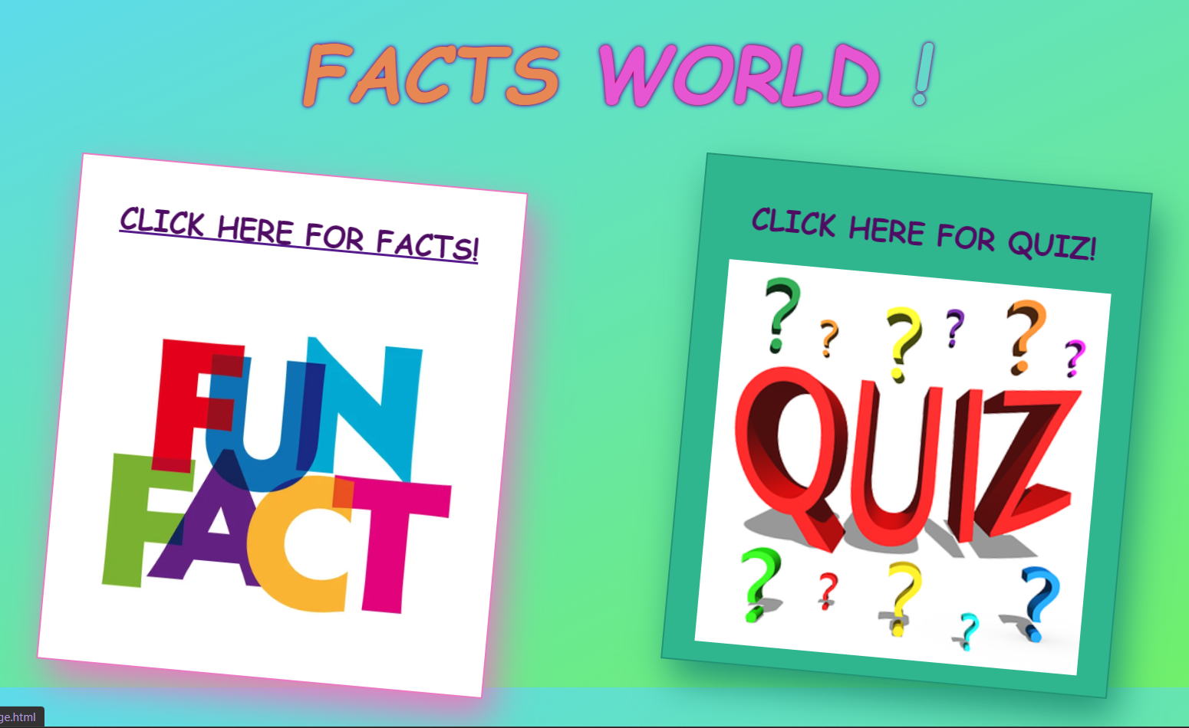

* ***FACTS PAGE:***
* ***This page displays 20 facts, one at a time.***
* ***Relevant images are also displayed with facts.***
* ***You can access the next /previous fact by clicking on the next/previous button present below the image.***
* ***It also has A HOME BUTTON in top-left corner from where you can return to the home page.***



|  |  |
| --- | --- |
|  |  |
|  |  |

* ***QUIZ PAGE:***
* ***This page is used to access the children after fact-reading.***
* ***It consists of 5 Random questions out of 20 facts (available on the facts page) with 2 choices for each question.***
* ***It checks if the option selected is correct or not and prints a relevant message.***
* ***It also displays the CURRENT SCORE continuously.***
* ***A single question is displayed at a time. Users can access the next question by clicking on SUBMIT button below the choices.***
* ***After completion of 5 questions submit button is DISABLED and the final score of the user is displayed***
* ***It also has A HOME BUTTON from where you can return to the home page.***

|  |  |
| --- | --- |
|  |  |
|  |  |

***WORKING***

* ***THE WEBSITE IS DESIGNED USING HTML, CSS, AND JAVASCRIPT.***
* ***The index.html file contains the code for the home page, facts_page.html for the facts page, and quiz_page.html for the quiz page.***
* ***Style.css file is used for styling all pages and is shared by all HTML pages.***
* ***Page.js is the JavaScript file. It is shared by facts and quiz page.***
* ***Animations are used in the style.css file to make the website appealing to kids.***

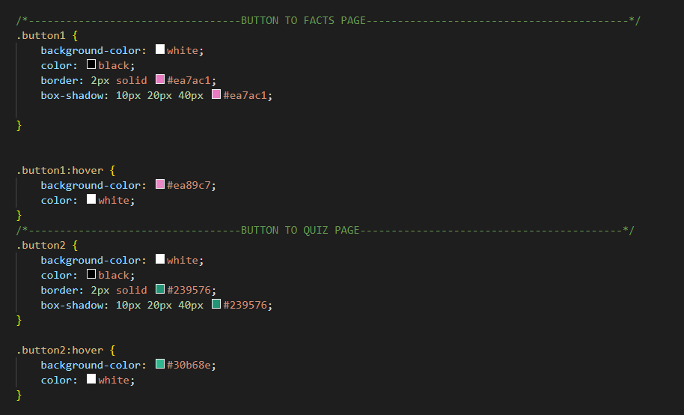

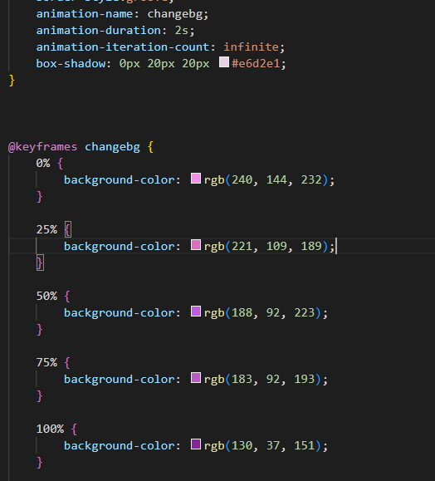

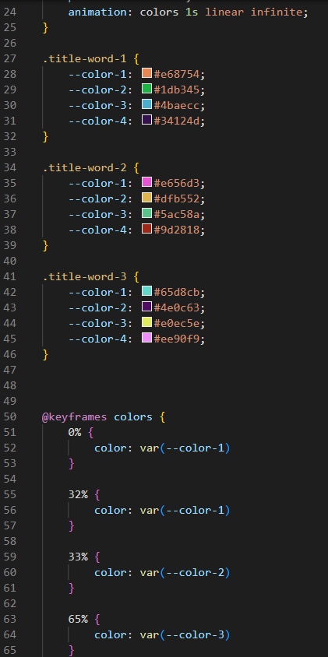

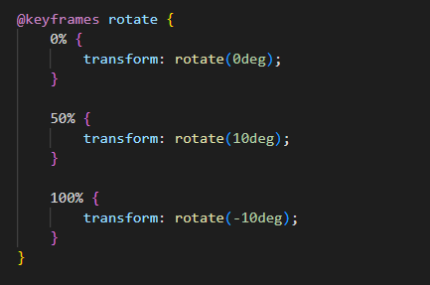

***And many more animations like these are used.***

* ***Functions to go to the next & previous facts, generate random questions, checking answers are used in the JavaScript file. Some examples are:***

